

MUTARE CITY COUNCIL

HALF YEAR BUDGET PERFORMANCE REVIEW

2021 YEAR BUDGET PERFORMANCE REPORT

INTRODUCTION

The year 2021 remains one in which COVID took a huge toll on national operations and our council was equally affected. Several lockdown restrictions were imposed by government in a bid to control infections. Operations were reduced to low levels and at the peak council operated at 10% of capacity. These restrictions meant reciprocal reduction of service delivery since critical human resources were not available to discharge some of the duties. Some of our staff members were infected by the deadly virus and the effects of this pandemic are too broad to quantify for now. This took a huge knock on our revenues but at the same time we had escapable fixed overheads which we still had to pay irrespective of economic slow down and reduced inflows. In such a pandemic residents became incapacitated to fully pay for their services due to job layoffs but at the same water, sewer and refuse collection services were in higher demand as a direct result of COVID 19. Council found itself in a dilemma in which residents were demanding more and better services which they could not afford but at the same time council had no alternative source of funding to provide the demanded services. We ended up rationalizing our operations to strike a balance and we hope for a better future as COVID statistics slow down.

Whilst the government has relaxed restrictions we remain alert to the effects of the pandemic and we call upon all to remain practicing safety measures as advised by our medical doctors such as social distancing, sanitizing, wearing face masks and getting vaccinated. Although it was such a tough year we managed to stabilize revenue inflows courtesy of several revenue enforcement initiatives that complimented each other leading to a relatively stable council.

REVENUE COLLECTION

A total of $1,230,785,171.58 was billed to June 2021 against a budget of $ 1 896 477 105.77 which is a 64,90% budget performance. New budget income lines could not be realised as initially planned due to slowdown in economic activity in the generality of the economy. Economic slow down has spiral effects on every sector and as a result this impacts on council collections and performance. We collected $ 701 110 735 for the same period against billing of $1,230,785,171.58 reflecting a collection efficiency of 57%. The daily average collections were $5.4 million per day. This collection includes US$ which were collected courtesy of our **“MAINTAIN UP TO DATE ACCOUNT”** promotion. Residents were enjoying the promotion but the coming in of SI-127 disrupted the momentum that we had gained with this promotion. We suspended the promotion for close to two months from 28 May 2021 to 23 July 2021 and only resumed after clarification with RBZ wherein it was clarified that this SI was targeting those who were abusing the forex allocated from the RBZ auction system. The table below shows monthly USD collections from January to June:

|  |  |
| --- | --- |
| **MONTHLY USD COLLECTION** | |
| **MONTH** | **TOTAL** |
| January | 95,239.16 |
| February | 94,651.57 |
| March | 212,927.33 |
| April | 214,679.34 |
| May | 254,362.67 |
| June | 106,494.94 |
| **TOTAL** | **978,355.01** |

Out of the $978,355.01, $258 824.98 is attributable to land sales.

The promotion continues to be affected by widening parallel market rates which erodes the benefit of the discount and in turn makes our promotion unattractive.

|  |  |  |  |  |
| --- | --- | --- | --- | --- |
| **FIRST HALF REVENUE**  **PERFORMANCE ANALYSIS** |  |  |  |  |
| **REVENUE STREAM** | **BILLING & ACCRUAL JAN- JUNE** | **RECEIPTS JAN - JUNE** |  |  |
| **WATER** | 361,723,454.40 | 131,662,598.00 |  |  |
| **SEWERAGE** | 109,174,806.05 | 58,671,482.00 |  |  |
| **RATES** | 175,240,070.83 | 102,696,461.00 |  |  |
| **SUPPLEMENTARY**  **CHARGES** | 106,885,501.12 | 55,026,256.00 |  |  |
| **RENTS** | 21,730,433.32 | 17,985,723.00 |  |  |
| **REFUSE** | 113,330,410.40 | 55,583,870.00 |  |  |
| **FIRE** | 34,765,403.89 | 14,086,753.00 |  |  |
| **EDUCATION LEVY** | 17,331,839.57 | 3,229,980.00 |  |  |
| **ST LIGHTING** | 17,325,531.86 | 7,186,498.00 |  |  |
| **ROADS CHARGE** | 29,624,325.14 | 11,327,719.00 |  |  |
| **NON BILLABLE** | 243,653,395.00 | 243,653,395.00 |  |  |
| **TOTAL** | **1,230,785,171.58** | **701,110,735.00** |  |  |

Out of the accrued $1,230,785,171.58 we collected $701,110,735.00.

**BUDGET PERFORMANCE**

|  |  |  |  |  |  |
| --- | --- | --- | --- | --- | --- |
|  | Budget | Billing | Budget  Performan ce % | Collection | Collection Efficiency  % |
| Jan | 316,079,517 | 203,796,972.37 | 64 | 50,827,283 | 25 |
| Feb | 316,079,517 | 228,599,079.57 | 72 | 78,405,767 | 34 |
| March | 316,079,517 | 190,543,837.29 | 60 | 138,356,855 | 72 |
| April | 316,079,517 | 190,514,065.24 | 60 | 134,048,383 | 70 |
| May | 316,079,517 | 206,661,363.94 | 65 | 145,214,436 | 70 |
| June | 316,079,517 | 210,669,853.17 | 67 | 154,258,010 | 73 |
| Total | 1,896,477,105 | 1,230,785,171.58 | 64 | 701,110,734 | 57 |

Our collection efficiency in greatly improving every month and we look forward to maintain that trend and surely our future is indicating right signals. We should all drive in the same direction and we will make great impact, which should be positively felt by our clients.

Monthly revenue collections as at 30 June 2021:



**MONTHLY REVENUE INFLOWS**

180,000,000.00

160,000,000.00

145,214,436.00

140,000,000.00

138,356,855.00

120,000,000.00

100,000,000.00

134,048,383.00

154,258,010.00

80,000,000.00

78,405,767.00

60,000,000.00

53,327,284.00

40,000,000.00

20,000,000.00

-

JANUARY

FEBRUARY

MARCH

APRIL

MAY

JUNE

**REVENUE COMPOSITION**

HEALTH GRANTS, 5,133,750.00

BEER LEVY, 2,960,339.59

NON BILLABLES, 60,672,343.10 ENDOWMENT, 698,443.71

FISCAL TRANSFERS , 7,346,637.00 WATER , 131,662,598.00

LAND SALES, 4,684,753.00

ZINARA GRANT, 10,536,086.40

MARKET FEES, 18,075,803.32

SEWER, 58,671,482.00

PARKING, 31,374,423.68

HEALTH FEES, 6,503,512.84

EMMERGENCY SERVICES, 31,897,903.31

RATES, 102,696,461.00

LICENCES, 95,036,626.68

BUILDING PLAN FEES, 22,549,445.37

REFUSE, 55,583,870.00

SUPPLEMENTARY CHARGES, 55,026,256.00

WATER SEWER RATES SUPPLEMENTARY CHARGES REFUSE BUILDING PLAN FEES LICENCES EMMERGENCY SERVICES HEALTH FEES PARKING MARKET FEES ZINARA GRANT LAND SALES FISCAL TRANSFERS NON BILLABLES HEALTH GRANTS ENDOWMENT BEER LEVY

# Consolidated Revenue by Programme

|  |  |  |  |  |  |
| --- | --- | --- | --- | --- | --- |
|  | **Budget Estimates** | **Projected Billings (Jan to June)** | **ACTUAL**  **(Own Revenue)** | **ACTUAL (GRANTS & OTHERS)** | **TOTAL REVENUE** |
| **PROGRAMMES** | amount | Amount | amount | Amount | Amount |
| Governance and  Administration | 161,355,693 | 63,104,253 | 42,012,173 |  | 42,012,173 |
| Water, Sanitation and Hygiene | 991,358,205 | 576,543,505 | 246,875,057 |  | 246,875,057 |
| Social Services | 1,011,072,019 | 245,593,175 | 176,895,170 | 5,133,750 | 182,028,920 |
| Roads | 489,338,698 | 29,771,682 | 26,920,909 | 17,882,723 | 44,803,633 |
| Public Safety and Security  Services | 1,134,434,996 | 309,472,641 | 184,562,226 |  | 184,562,226 |
| Natural Resources Conservation and Management | 5,394,600 | 828,725 | 828,725 |  | 828,725 |
| **TOTALS** | **3,792,954,212** | **1,230,785,171** | **678,094,262** | **23,016,473** | **701,110,735** |

We should invest more in improving our natural resources monitoring in order to protect our future and to harness more revenue from our natural resources. The performance of this program is very poor hence we should take action.

# REVENUE FUNDING SOURCES

REVENUE SOURCES

800,000,000.00

**678 094 262**

700,000,000.00

600,000,000.00

500,000,000.00

400,000,000.00

300,000,000.00

200,000,000.00

**, 23,016,473.00**

100,000,000.00

-

OWN REVENUE

GRANTS

Revenue from own funds contributed 97%, grants contributed 3% of the total revenue.

REVENUE DISTRIBUTION BY PROGRAMM

# EXPENDITURE SUMMARIES

|  |  |  |  |  |
| --- | --- | --- | --- | --- |
| **Expenditure** | **Budget** | **ACTUAL PERFOMANCE** | **VARIANCE** | **VARIANCE**  **%** |
|  |  |  |  |  |
| Compensation of  Employees | 440,427,023.52 | 323,792,611.74 | 116,634,411.78 | 45.89 |
| Use of Goods and Services | 880,689,960.96 | 189,069,117.30 | 691,620,843.66 | 26.79 |
| Repairs & Maintenance | 626,797,159.19 | 37,217,472.38 | 589,579,686.81 | 0.05 |
| Assets Acquisitions | 1,713,188,456.44 | 155,539,466.92 | 1,557,648,989.52 | 27.27 |
| **TOTALS** | **3,661,102,600.11** | **705,618,668.34** | **2,955,483,774.92** | **100.00** |

We are planning to setup a fully resourced GIS section in the next budget circle in order to lay a solid platform on which our vital statistics are always updated and will facilitate correct planning. Our target is to have completed the GIS data capture by end of year 2023. We are proposing a fully-fledged GIS section independent from departments in order for us to improve its efficiency.

PERFORMANCE ACCRUED EXPENDITURE JAN - JUNE 2021

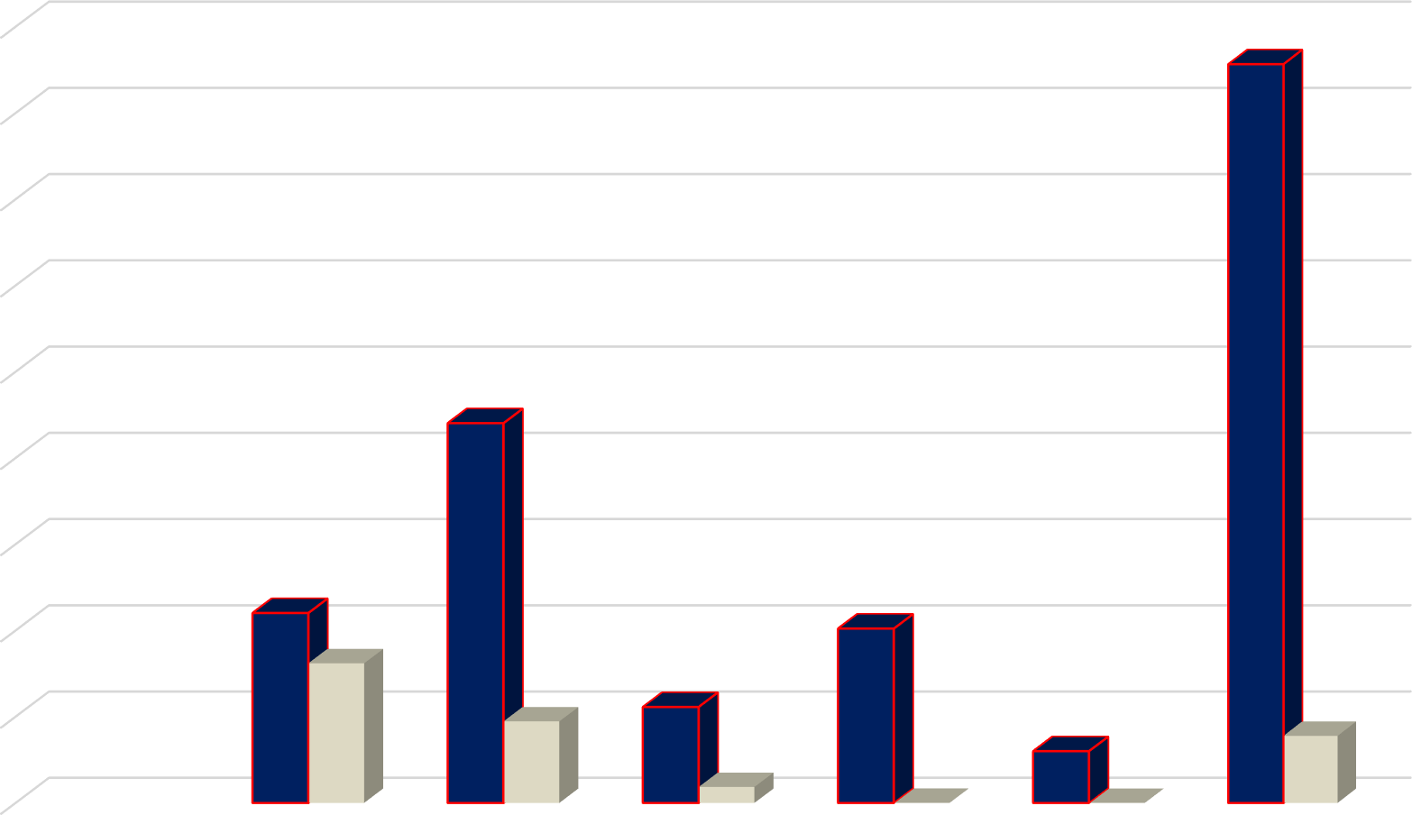

1,800,000,000.00

1,600,000,000.00

1,400,000,000.00

1,200,000,000.00

1,000,000,000.00

800,000,000.00

600,000,000.00

400,000,000.00

200,000,000.00

-

Compensation of Employees

Use of Goods and Services

Maintenance Repairs Consumption of

fixed capital

Assets Acquisitions

Budget ACTUAL PERFOMANCE

# SALARIES

Expenditure for salaries was $323 792 612 which consumed 45.88% of the total expenditure. When we submitted our budget salary for the lowest paid workers was pegged at average $5000 which is no longer sustainable. Due to inflation and the economic instability in the country, we had to increase salaries for workers. The employees were incapacitated to continue coming to work. By the end of the first half of the year salaries expenditure consumed 71.51% of the total salaries budget. Council has managed to pay off all statutory obligations on or before due dates and we enjoy cordial relations with our statutory creditors.

We have managed to provide our junior staff members a competitive salary in relation to our sector, however the salary has remained low as compared to the inflation levels. Without a budget tariff increase it has become impossible to give our employees a meaningful salary increase but we have kept live engagements between the employees and employer in order to facilitate dialogue for mutually agreed position on way forward.

# OPERATIONAL COSTS

Operational costs were $189,069 117.30 and took 26, 79% of the total expenses. The economic instability in the country remains a challenge and is impacting on service delivery. All our suppliers are rating and charging on the basis of parallel US$ value every time there is movement in exchange rates for US dollars. Our inputs costs have significantly increased, in worst cases by 3 times due to unstable forex market. Service delivery is no longer sustainable.

The main cost drivers for Council in the period ending 30 June 2021 were:

* + Fuels
  + Electricity
  + Water Chemicals
  + Water Extraction Charges

# CAPITAL EXPENDITURE

Capital expenditure took 22.04% of the total expenditure which was $705,753,668.34 as at 30 June 2021. We however registered positive strides in the following selected projects:

1. Procurement of tippers*2
2. Procurement of a motorized Grader
3. We look forward to take delivery of an iron roller before end of November 2021
4. Procurement of utility Vehicles
5. Investment in ICT Servers & computers 7- Maonde electrification
6. In-line chlorinators for T section
7. Dangamvura cemetery toilet
8. Major renovations to Sakubva Stadium
9. Rottery mowers for parks and gardens
10. 3.7km Magamba drive road reseal/ reconstruction
11. 31.9km Tar pothole patching of various CBD and main roads (Herbet Chitepo, 2nd St, Leopold Takawira, Feruka rd, St Joseph rd)
12. 4.3km Kumbirai Kangai (Aerodrome rd) road reseal. 16- 2km Musikavanhu Drive (Dangamvura rd) reseal
13. 1.6km gravelling Chikanga St Joseph road
14. Two ambulances procured (one yet to be delivered)
15. Procured Equipment for Gimboki Clinic
16. Command Vehicle for firestation
17. Equipment for City & Sakubva Health Care Clinic 24-
18. Sakubva & Chidzere flea market fencing.
19. Procured two, 4 tonne trucks for parks and engineering
20. Dangamvura Water project



# CAPITAL EXPENDITURE FUNDING STRUCTURE

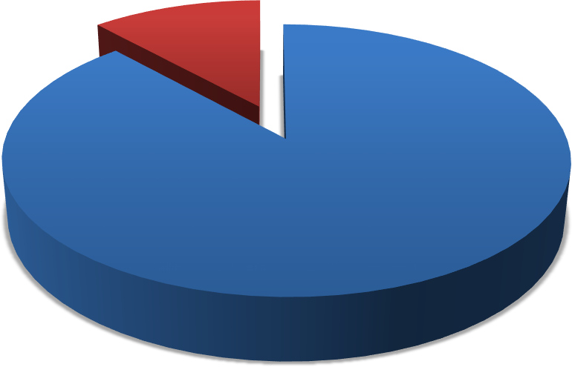

**FUNDING SOURCES**

GRANTS, 18,179,723.40 ,

OWN REVENUE,

137,359,743.52 , 88%

OWN REVENUE GRANTS

**DONATIONS**

We received the following items through donations. Most donations came in for Covid -19

|  |  |  |  |
| --- | --- | --- | --- |
| **DONOR** | **ITEMS** | **VALUE** | **RECEIVING DEPARTMENT** |
| Common Wealth | 4 DESKTOP COMPUTERS & 1 LAPTOP | 926,900.61 | Housing & Community  Services |
| Mutare District Phamacy | COVID -19 TEST KITS | 1,962.88 | Pharmacy |
| MPH | COVID -19 TEST KITS | 47,779.59 | Pharmacy |
| PMD | PCR Test kit | 26,456.19 | Rapid response team |
| MPH | MEDICAL DRUGS | 4,652.05 | Pharmacy |
| Every Life matters Funds | Brush cutter twine | 9,921.07 | Health Depot |
| MPH | Covid-19 antigen test kit B/25 | 4,652.05 | Pharmacy |
| Tanganda Tea | PROTECTIVE CLOTHING | 30,813.55 | Grave Diggers(Housing) |
| Global Hope Mobilization | medical equipment | 208,508.37 | MIDH |
| MPH | Medical drugs and test kits | 243,235.59 | Pharmacy |
| GGZT | Dish washer (5l) | 5,000.47 | City Health Department |
| WLSA | sanitizes, soaps sanitary pads | 19,574.71 | City Health Department |
| Sakubva Helper UK | 650 Fiction and non fiction books | 58,799.52 | Library |

|  |  |  |  |
| --- | --- | --- | --- |
| Every Life matters Funds | brush cutters, stretcher beds mattresses | 289,223.28 | MIDH |
| WHO | SKM Motor cycle with accessories | 329,176.80 | City Health Department |
| AHF | desks, chairs, printer, projecter, iter 56, benches  cabinet | 649,915.12 | SOPD |
| Every Life matters Funds | Standard Bedside lockers | 125,835.00 | MIDH |
| MOHCC/ICAAP | sumsung galaxy tablets A65*9 | 2,003,293.20 | Clinics |
| Mutare District Pharmacy | disposable gowns, sanitizers | 43,287.24 | Pharmacy |
| Idai Recovery Project | medical equipment | 48,991.76 | Pharmacy |
| Comhold | scour blowers and airconditioner | 7,907,925.24 | Odzani and Gimboki |
| Common wealth local Government  Forum | hp destop and hp laptop | 926,900.61 | Housing LADS implementation |
| Natpharm | Acyclovir 200mg | 12,751.28 | Pharmacy |
| UNICEF | Hand sanitizer 500mls | 251,670.00 | MIDH |
| MoHCC | Penguins | 80,620.80 | Civic center Health  Department |
| CeSHHAR | face masks, sanitizers,rescue blankets | 289,563.04 | Sakubva Clinic |
| MSF-Belgium Project | medical equipment | 2,228,017.95 | Pharmacy |
| Nathaniel Machini | 100 Fiction Books | 16,823.94 | Library |
| Care International | 3 Tippy tappy buckets | 21,955.24 | Housing |

|  |  |  |  |
| --- | --- | --- | --- |
| MPH | Covid-19 antigen test kit B/25 | 9,452.46 | Pharmacy |
| MoHCC | Solar flood lights | 2,196.55 | Dangamvura Clinic |
| Mr Fon and Seven sisters | Royal Cuban Palm trees | 13,517.22 | Dangamvura Clinic |
| Dangamvura East UMC RRW | pine gels . Dish washing liquid | 1,605.17 | Dangamvura Clinic |
| Life international Zimbabwe | Office Chairs | 76,920.66 | Dangamvura Clinic |
| Mohcc through UNDP | 15 Panel solar | 7,352.26 | Sakubva Health Center |
| PMD | 20l diesel | 2,231.54 | Civic center Health  Department |
| WHO ZIRP Project | Surgical face masks B/50 | 825,840.51 | Pharmacy |
| MPH | Covid-19 antigen test kit B/25 | 4,399.93 | Pharmacy |
| Mercy Corps | Surgical face masks B/50 | 13,967.15 | City Health Department |
| Care International | Covid 19 sensitisation billboard | 17,482.50 | Housing Sensitisation |
| DA's Office | Tippy tap bucket | 7,329.75 | Housing |
| Kufema Zimbabwe | Oxygen respirators | 31,968.75 | MIDH |
| PMD | Diesel coupons | 87,978.00 | City Health Department |
| Mutare Bottling Company | Sprite cans 330mls | 4,140.00 | Chamber Secretary |
| Kufema Zimbabwe | Oxera Kit | 19,239.68 | Housing Sensitisation |

|  |  |  |  |
| --- | --- | --- | --- |
| Corpaid | Corpaid | 4,446.50 | Housing |
| NAC | Water based lubricants | 487,405.29 | MIDH |
| **Total** |  | **18,431,681.11** |  |

# ACCOUNTS RECEIVABLES

Below is our Debtor’s age analysis as at 30 June 2021. The level of debtors confirms that there is growing need for Council to intensify debt collection in order to reduce these debtors. We also have dormant debtors whose accounts are not serviced which the legal section should pursue and finalize. We are working with our credit control team to separate problem clients from the rest so that these are pursued separately and require a different approach from the rest. Our major Debtor is Mutasa RDC who only paid $3 million in the current year out of a total billing of $69 million on the date of this report. We have instructed our new lawyers to demand payment and this has already been done and we await feedback on how they will defend. Their failure to pay for water supplied has also contributed immensely to the implementation of a new water rationing regime. Our capacity to produce more water is now greatly compromised due to lack of resources. We are now providing a maximum of 2 days water supply per week. If no payments come we will completely disconnect services. We look forward to Mutasa RDC engaging and to contribute its part to the production of water.

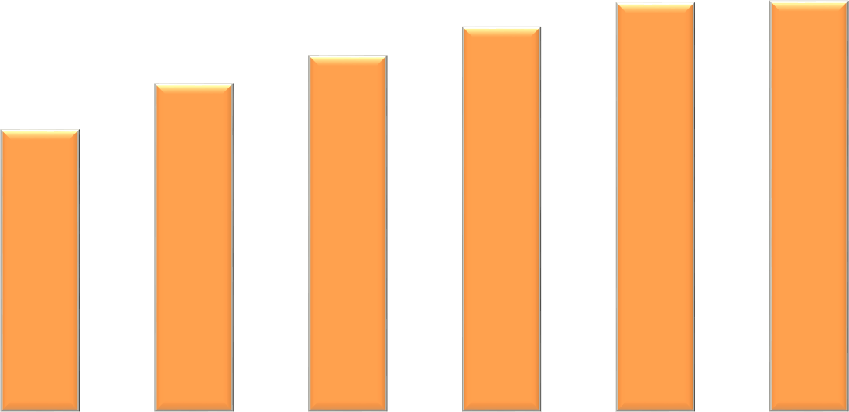

**DEBTORS TREND**

900,000,000.00

800,000,000.00

829,439,406.01

700,000,000.00

721,612,510.00

600,000,000.00

779,631,393.62

664,537,001.00

832,184,570.63

500,000,000.00

571,131,451.89

400,000,000.00

300,000,000.00

200,000,000.00

100,000,000.00

-

JANUARY

FEBRUARY

MARCH

APRIL

MAY

JUNE

The increase in tariffs in January 2021 compounded by poor macro-economic performance induced by Covid-19 prevailing in the country resulted in poor budget performance. Debtor’s figures are on the rise. In the first quarter the closing figure for debtors was well over $721 million. By close of June the figure rose by an estimated 15 % to close the quarter at over $832 million. Although debtors have been increasing , we however managed to reduce the rate of increase. From our billing we are now collecting an average of 70% and this means the 30% uncollected bill increases our debtors’ balance. We are employing more strategies to enforce for collection and our first batch of summons were served and the messenger of court is busy executing for recovery. This is sending signals to residents that council dues should be paid and we have seen some coming in for payment plan arrangements with our debt collection team. We hope our collection efficiency continues to improve every month as shown in the upward collection trend from 31% in January to June 70%. This is very impressive performance especially when you consider the tough COVID environment. We should continuously capacitate our revenue team to continue in this trajectory.

# CREDITORS AGE ANALYSIS AS AT 30 JUNE

CREDITORS TREND

18,000,000.00

16,312,606.70

16,000,000.00

14,000,000.00

13,465,031.00

12,000,000.00

10,938,032.54

10,000,000.00

9,719,934.00

8,000,000.00

9,263,879.00

6,000,000.00

7,818,990.00

4,000,000.00

2,000,000.00

-

JANUARY

FEBRUARY

MARCH

APRIL

MAY

JUNE

Our creditors increased by from $10 ,9million in first quarter to $16,3 million by end of the second quarter which is a 67% increase, with major creditors being:

* Pungwe subcatcment
* Zimbabwe insurance brokers(ZIB)
* ZINWA

However these creditors’ (ZIB and ZINWA) balance are in current in terms of aging and are not overdue since the current charges are paid off before end of the following month of receiving bills. We however have not paid Pungwe for 2021 invoice mainly because of sticky issues around water that is consumed through Tsonzo & Sakupwanya Offtakes in Mutasa district for rural communities. We have engaged Pungwe sub catchment to revise our bill to remove that which relates to raw water consumed in Mutasa by rural consumers. We have not reached an agreement yet but as soon as this is finalised we will pay off.

We have a very positive current ratio due to very low liabilities which give confidence and confirms our going concern status as very healthy. More still needs to be done to reduce debtor’s levels.

FINANCE DEPARTMENT PROJECTS

|  |  |  |
| --- | --- | --- |
| **PROJECTS** | **Section** | **Progress** |
| Motor Vehicles- 1 New vehicle | Stores Section | 1 vehicle was delivered for stores section and one more new vehicle & 15 motor bikes are expected Before year end |
| Furniture & Fittings | Several sections | Procured for several offices and Dangamvura new offices |
| Meter reading & Receipting Gadgets | Revenue Section | On Tender |
| Computer Equipment | All Finance Sub-sections | Procured |
| Self Service Smart Gadgets | Meter readers | Deferred to next year |
| Banking Hall Renovations | Revenue | Tender failed. Retendered targeting first quarter 2022 |
| Systems Integration ( Promun, LADS etc) | All Sections | Partially done. Axis yet to allow |

|  |  |  |
| --- | --- | --- |
| LADS new modules | All Sections | New Lads lab to be opened |
| NEW ERP | All Sections | New ERP to be developed with partial funding from CLGF |
|  |  |  |

DEVOLUTION FUNDED PROJECTS

When we submitted our 2021 budget City of Mutare was set to get $192,047,900 million from the central government which was planned to fund the following projects:

|  |  |
| --- | --- |
| 1. Dangamvura Water Project | -$120,507,900 |
| 2. Roads | -$30,000,000 |
| 3. MIDH | -$10,000,000 |
| 4. Sakubva Stadium | -$10,000,000 |
| 5. Yellow Equipment (Roads) | -$21,540,000 |

Up until June 2021 Mutare City Council had not received any devolution ($192 million) grants for 2021. As a result no planned projects were done in the first half of 2021. We however received $7,3 million under a new government funded special roads program for year 2021 and an additional $$5,133,750 was received for COVID 19 allowances for health department staff. However we received $20 million in the third quarter of 2021 which was channeled to Dangamvura water ($9,369,098) and the balance $10,630,902 was channeled to roads.

LOAN FUNDED PROJECTS

Council applied for approval of borrowing powers and the application was submitted to the parent ministry and is yet to be approved by the minister of finance. If approved this loan facility is targeting to fund the following projects:

|  |  |  |  |  |
| --- | --- | --- | --- | --- |
| **PROJECT** | **SOURCE** | **SECTION** | **US$** | **AMOUNT** |
| City wide Water augmentation | LOAN | Water | 200,000 | 16**,** 600.000.00 |
| Water Bowser x 1 | LOAN | Water | 100,000 | 8,300.000.00 |
| T-35 x 2 | LOAN | Roads / Parks | 140,000 | 11,620.000.00 |
| Fire tender x1 | LOAN | Fire | 100,000 | 8,300.000.00 |
| Refuse truck x2 | LOAN | Environment | 200,000 | 16,600.000.00 |
| Dump trailer x1 | LOAN | Environment | 15,000 | 1,245,000.00 |
| Excavator x1 | LOAN | Roads | 200,000 | 16,600.000.00 |
| Road maintenance x1 | LOAN | Roads | 500,000 | 41,500,000.00 |
| New flea market x1 | LOAN | Housing | 100,000 | 8,300.000.00 |
| Procurement of water Bowser x1 | LOAN | Roads | 100,000 | 8,300.000.00 |
| Dangamvura and Fern Valley water project | LOAN | Water | 250,000 | 20,750,000.00 |
|  |  |  |  |  |
| **TOTAL** |  |  | **1,905,000** | **158,115,000** |

# DEVOLUTION PROJECTS IMPLEMENTED

**Dangamvura water project**

|  |  |  |
| --- | --- | --- |
| **DANGAMVURA WATER PROJECT** | **USD** | **ZWL** |
| 2021 BUDGET |  | 120,507,900.00 |
| Expenditure Incurred to date | 366,236.92 | 32,430,279.27 |
| Council contribution |  | 23,061,180.80 |
| Devolution Funds contribution |  | 9,369,098.47 |
| Remaining works to completion | 190,255.44 | 16,847,119.21 |
| TOTAL PROJECT COST | **556,492.36** |  |
| % of completion | 93% |  |

# CAUSES FOR PROJECT DELAY

|  |
| --- |
| * Materials on Orders/tender but not yet delivered |
| * Suppliers not willing to deliver before prepayment is done * Suppliers not willing to give deposit guarantees |
| * Failure of contractors engaged by ADB which is delaying delivery of steel pipes imported from South Africa * High price variations leading to contract cancellations |

ZINARA GRANTS

We had received $10,536,086.40 against an expected amount of $124,000,000.00. We look forward to receive the balance in the last quarter of the year. The received amount was channeled to emergency works. Reconstituted ERRP2 Budget allocation for City of Mutare is **ZWL 81 799 533.22. and the a**mount disbursed so far is **ZWL30 845 046.08**. Mutare provided Internal funds to the same road rehabilitation cause and so far **ZWL 22 116 180.38** plus and extra **$65** million has been committed for disbursement upon completion of works and submission of certificates**.**

|  |  |  |  |  |  |
| --- | --- | --- | --- | --- | --- |
| Road project and scope | Approved Budget (ZWL) | Committed Amount (ZWL) | Actual Expenditure | Comment s | Project Status |
| 1.3km Kumbirai Kangai road reseal (Lot 3) | $37 122 465.40 | $22 694 940.71 | $20 308 956.68 | **ZINARA/ ERRP2**  **paid** | 100 % complete |

|  |  |  |  |  |  |  |  |
| --- | --- | --- | --- | --- | --- | --- | --- |
| 0.9km Kumbirai Kangai road reseal (Lot 1) | $9 282 783.02 |  | $7 293 908.70 |  | Own funds | 100 % complete | |
| 1.1km Kumbirai Kangai road reseal (Lot 2) | $10 685 234.33 |  | $7 647 470.86 | Devoluti on | | 100 % complete | |
| 1km Kumbirai Kangai road reseal (Lot 4) | $22 107 809.43 |  | $14 822 271.68 |  | Own funds | 100 % complete | |
| 31.9km Tar pothole patching of various CBD and main roads **(Herbert Chitepo st, 2nd street, Leopold Takawira rd, Feruka rd, St Joseph rd, Simon Mazorodze)** | $18 935 952 | $21 576 681.81 | $2 034 788.05 | **ERRP2**  **funded** | | 66% completion | |
| Gimboki Shelvert Repair | USD 30 000 | USD30 000 | USD13 868 | **ERRP2**  **funded** | | 88% gravel backfill done | |
| 4th street road repair and reseal (0.65km) | USD123 061.42 |  |  | MCC own funds | | 40% Works progress.  Contracted CMED |  | |
| 0.75km Bonda road, road repair and reseal | USD96 542.94 |  |  | **ERRP2**  **funded** | | Contractor on site (CMED) | |

|  |  |  |  |  |  |
| --- | --- | --- | --- | --- | --- |
| 1km Merewe street gravelling | USD64 808.72 |  |  | **ERRP2**  **funded** | Contractor handed site (CMED) |
| 8.4km Magamba drive road reseal/ reconstruction/upg rading | USD 1 094  800.30 |  |  | Roads handed over to PRE | Contractor on site |
| 2km Musikavanhu drive road reseal | USD221 315.09 |  |  | Roads handed over to PRE | Contractor on site |
| 2km Jelf to Hobhouse road | USD 497 580.36 |  |  | Roads handed over to PRE | Contractor on site |

**Progress as at October 2021**

1. **4.3km** Kumbirai Kangai road resealed…100%

**21.02km** out of 31.9km various roads tar pothole patched …66%

St Joseph road 1.6km gravelling out of planned target of 3.1km….52%

* + Feruka road (10.6km): 8km Feruka road, Tar patched. The works being funded under ERRP2…95%

**ZINARA & ERRP PROJECTS-**

**CITY OF MUTARE**

**Kumbirai Kangai road ( Aerodrome Road)**

* The road is one of the major commuter routes in the City of Mutare and is 4.3km long from the CBD.
* It services one of the biggest townships of Chikanga and is a through road to other townships west of Chikanga.
* The road was in a very poor state with multiple potholes and crocodile cracks on most sections which rendered the road surface untrafficable.
* Pothole patching, slurry sealing, opening of side drains and resealing was done and completed on the entire stretch and the road is now open to traffic.
* The works are a long-term solution as continuous pothole patching was no longer sustainable in terms of cost – benefit due to continuous eruption of potholes shortly after patching.
* The works have greatly improved the riding surface and the motorists are forever grateful for the intervention.
* The quality of work is good, and works are to standard. This will see the Council focusing on other roads in the coming years.
* The application rates used are 1.3litres/m2 for bitumen and 0.013m3/m2 for 13mm precoated surfacing stone and the rates are acceptable.
* The project cost is USD237,504.71 for Lot 3 which is 1km being paid for using the road fund. The other Lots are being funded from the City internal resources.
* The project was fully implemented

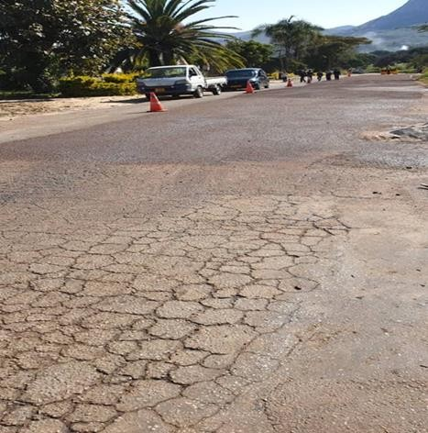

Crack sealing and slurry sealing

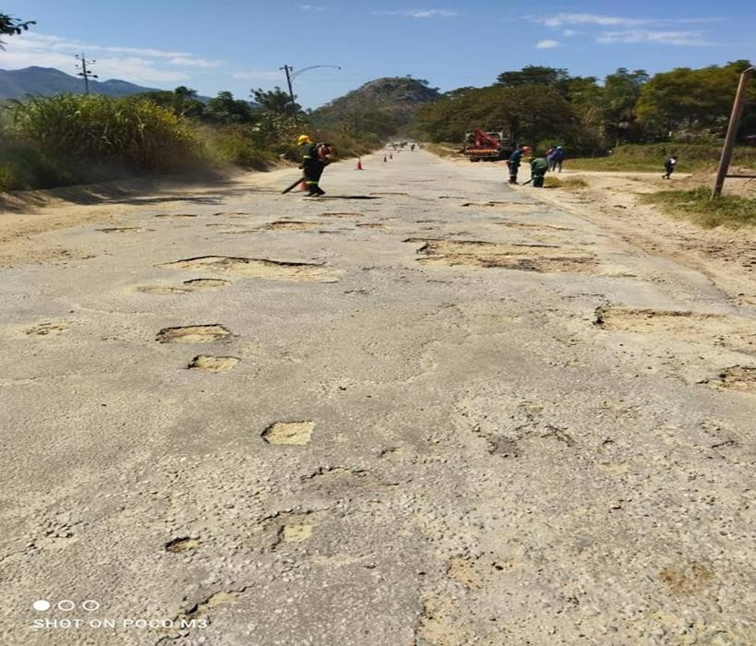

Potholes before patching

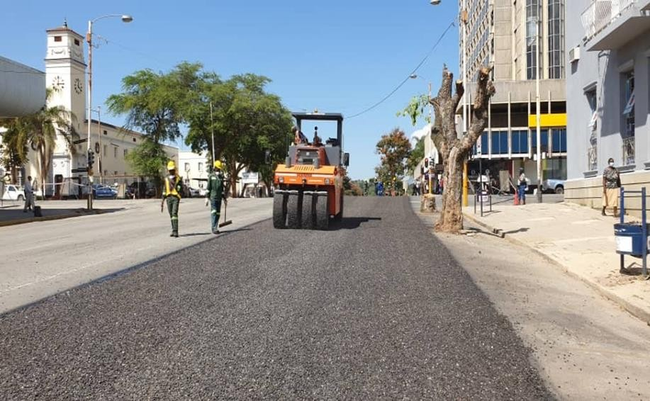

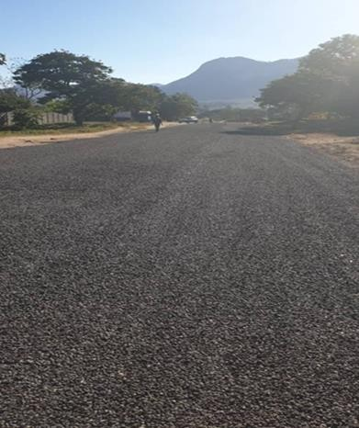

**Road condition After**

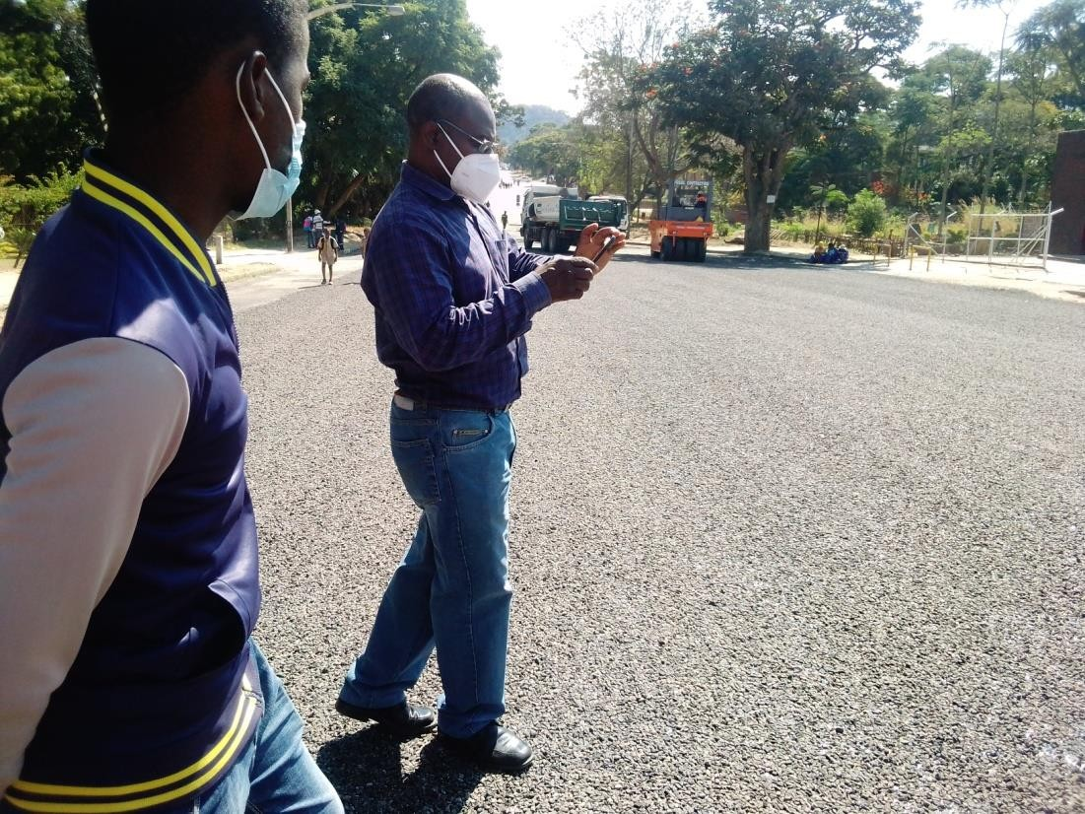

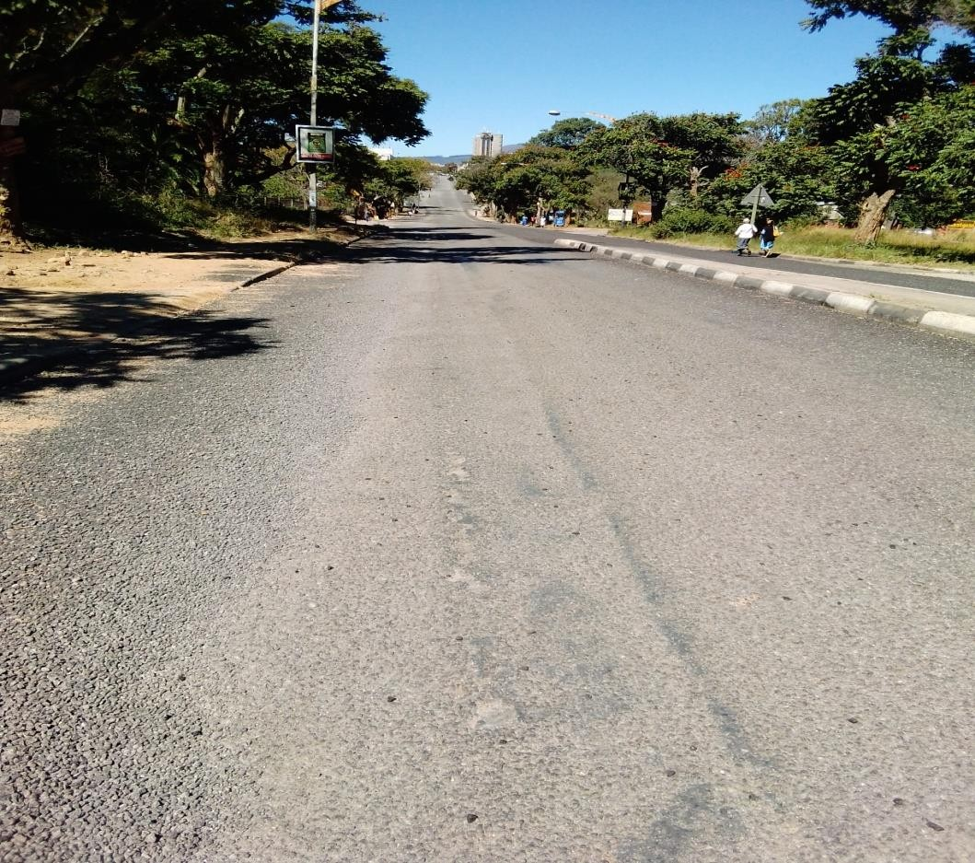

**Kumbirai Kangai**

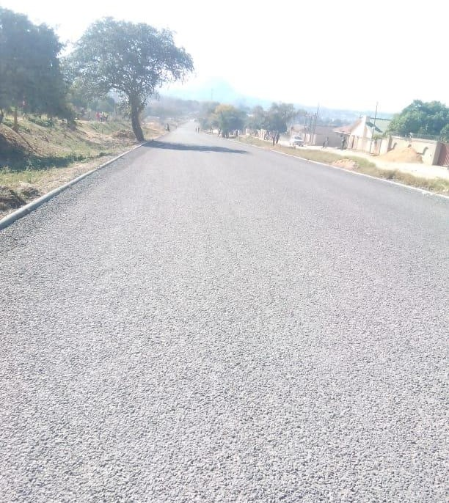

**Kumbirai Kangai road, Chikanga 2 view after works.**

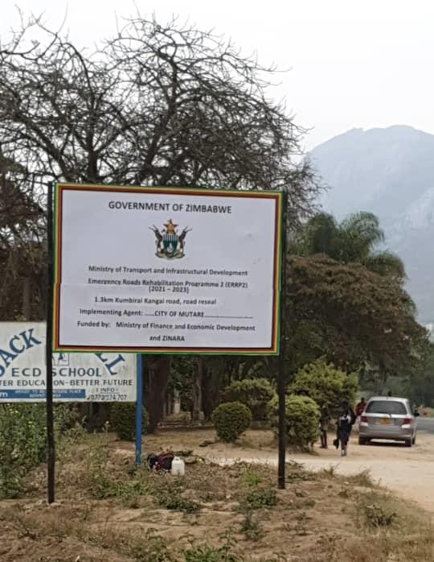

**St Joseph road**

* The road is one of the commuter routes in the City of Mutare and is 1.6 km long from Sakubva to Chikanga St Joseph area
* The road has gravel road section and a surfaced section both which are in a very poor state with galleys potholes most sections which rendered the road untrafficable.
* 2250m3 of Gravel dumping has been completed in preparation for gravelling i.e spreading a and compacting
* V drains will be opened using a grader
* Project was allocated RTGS$ 3, 179,232.00 ERRP2 phase 1

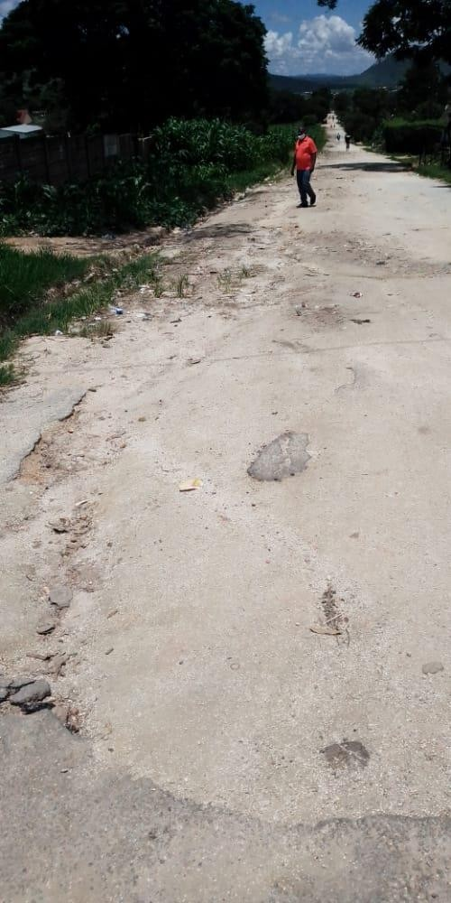

**St Joseph Before**

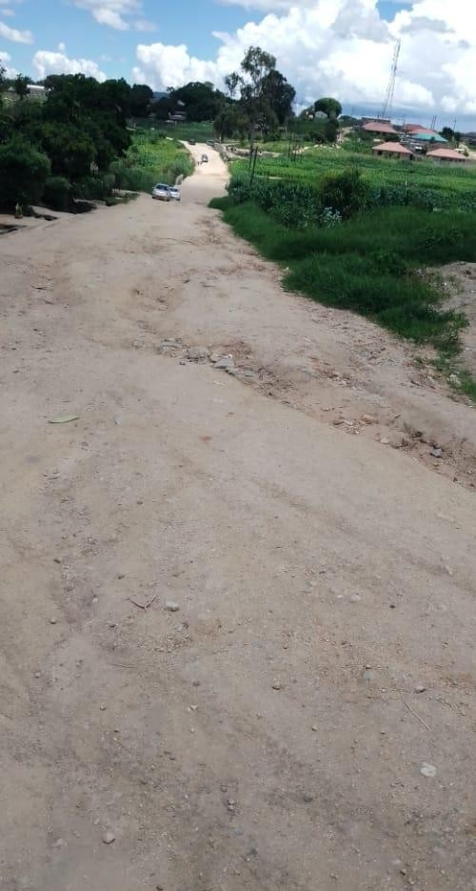

S**t Joseph Before**

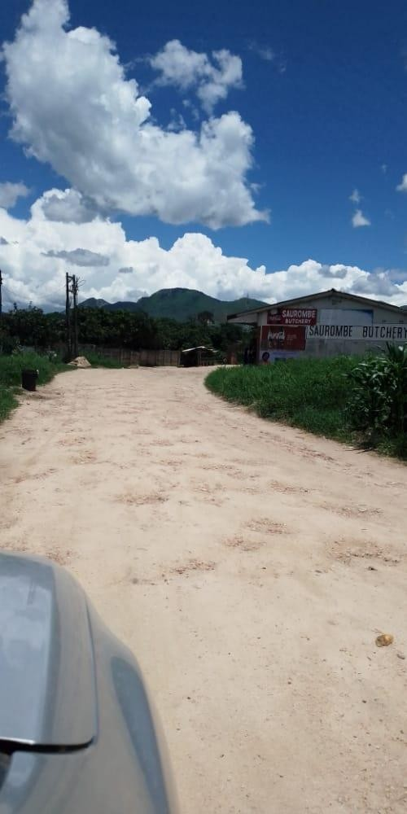

**St Joseph Before**

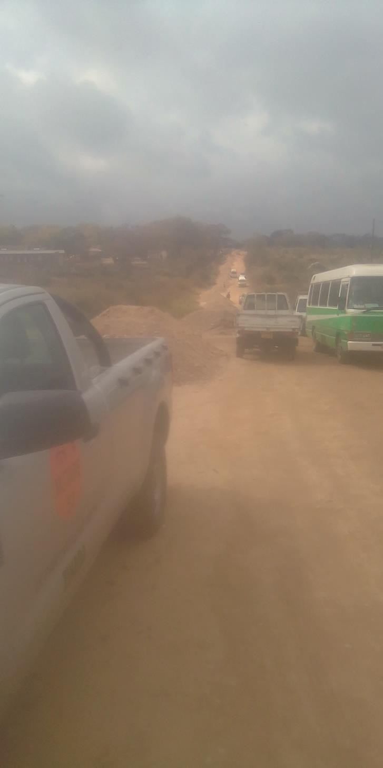

**St Joseph Work in progress**

**Feruka road**

* **Feruka road** runs for 12km linking Feruka Oil Refinery to Chimanimani road which is one of the regional truck routes. The Feruka Oil Refinery is of National strategic importance. National fuel coming from Beira via the pipeline passes through this deport with an option of fuel being transported via road dispatched from this deport to Harare and other towns. The road is a national lifeline and allowing this road to deteriorate will starve the Nation of the much needed fuel for industry and business apart from the commuting public. The road also links Dangamvura, Weirmouth and Hobhouse suburbs serving a population in excess of 100 000.
* 10.6 km of the road was in a bad state
* Cement stabilized gravel patching and tar patching has been done on 9.15km of the road and 120m3 of hot premix was used
* The project was allocated RTGS$ 11, 155, 200.00 under ERRP2 Phase 1

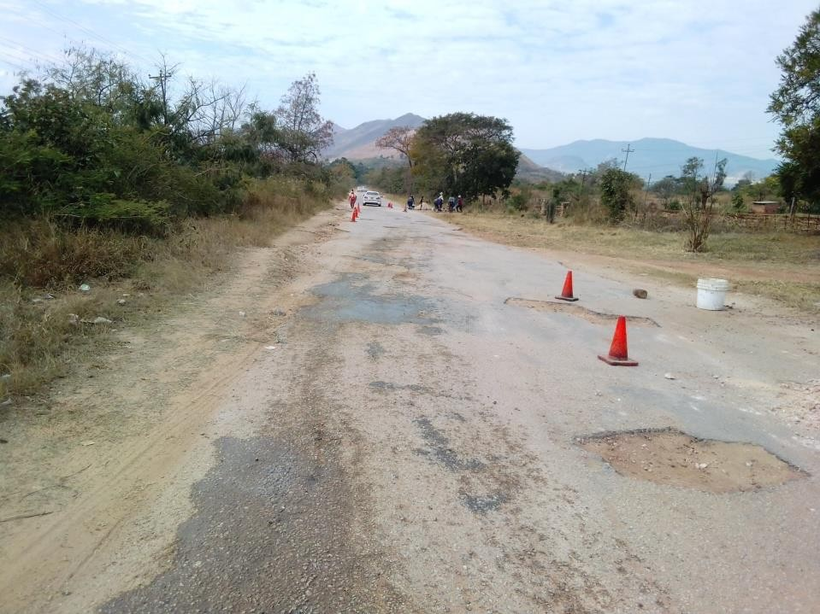

**Feruka Road Before**

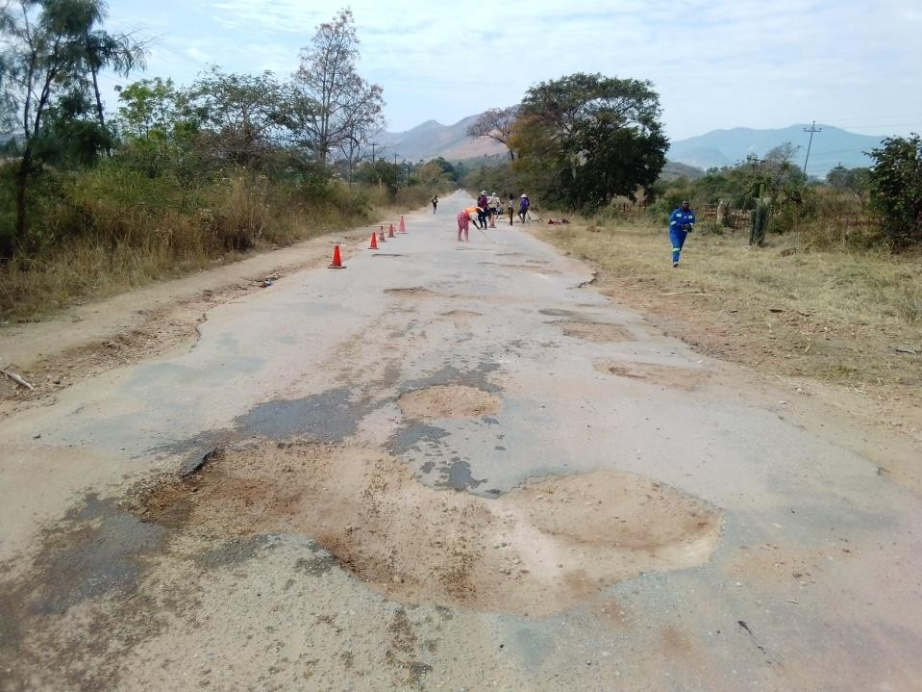

Feruka Road Before

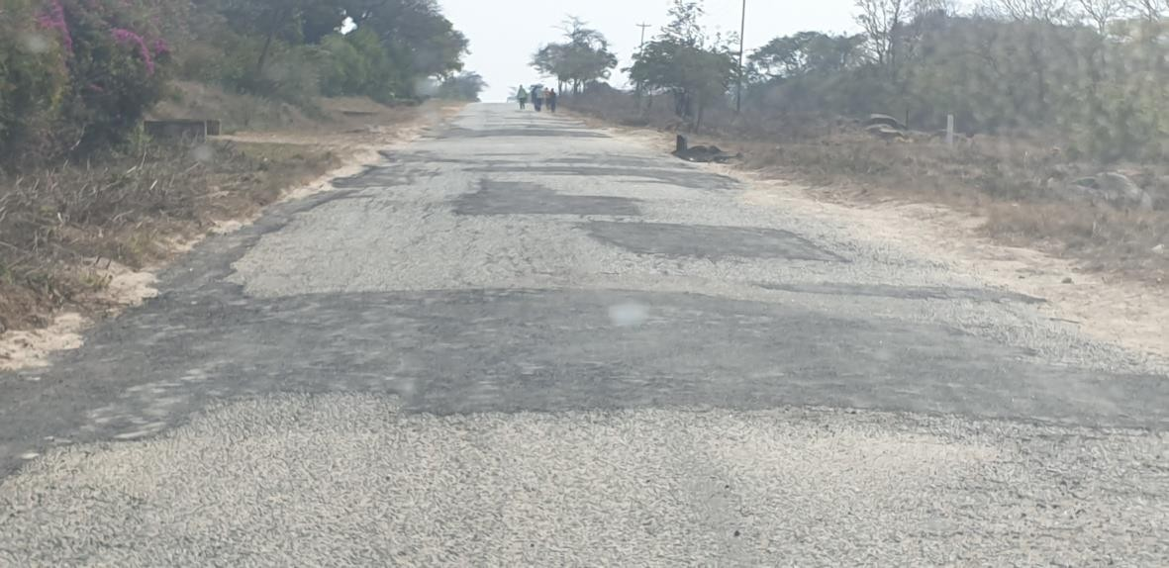

**Feruka road after**

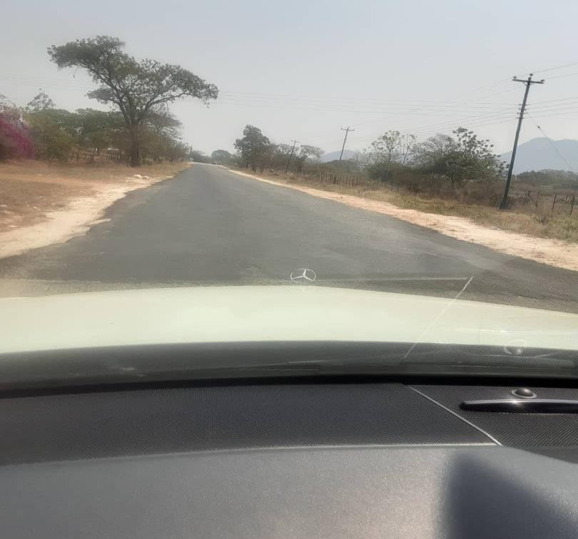

**Feruka Road After**

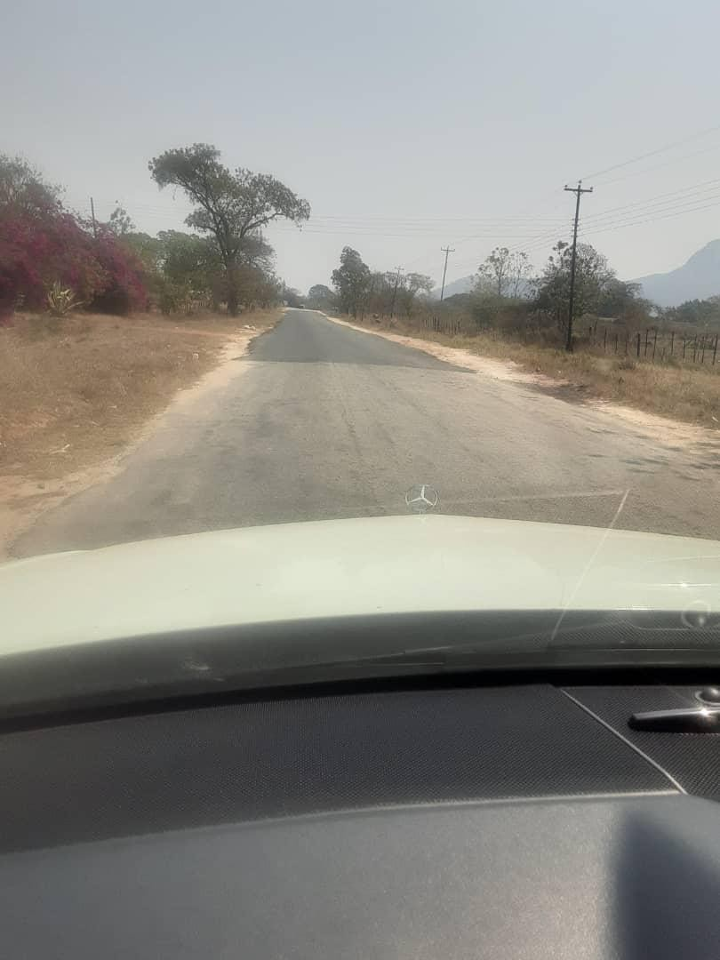

**Feruka Road after**

**Gimboki Shelvert**

* Dangamvura area 3 Shelvert bridge
* The shelvert bridge suffered erosion on the downstream side which affected the road carriage way. There has been massive undercutting and looming danger of total bridge collapse. The intended intervention works include backfilling and slope protection.
* The bridge is on a main road linking Dangamvura area 3 and Dangamvura Greenmarket and it is a vital link.
* Work is in progress and 70% embankment backfill complete

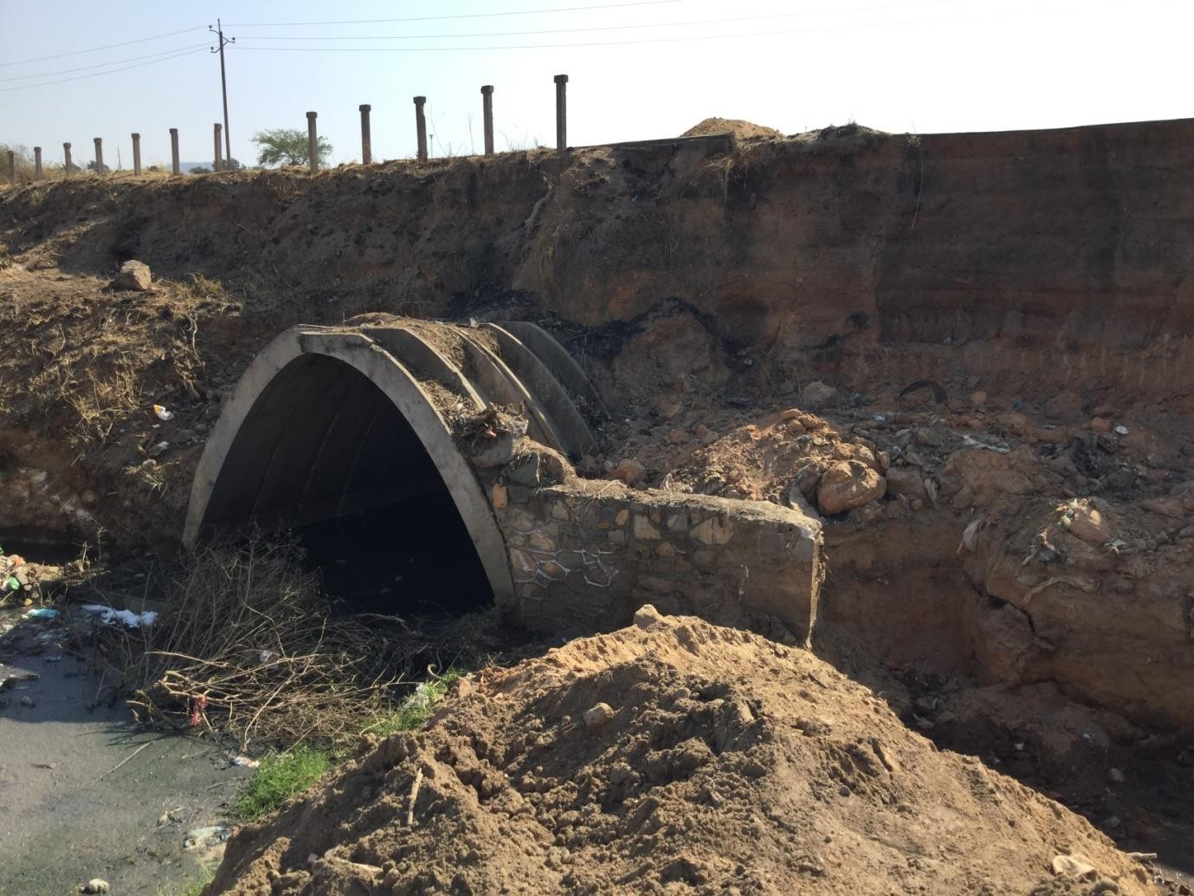

Gimboki shelvert before..

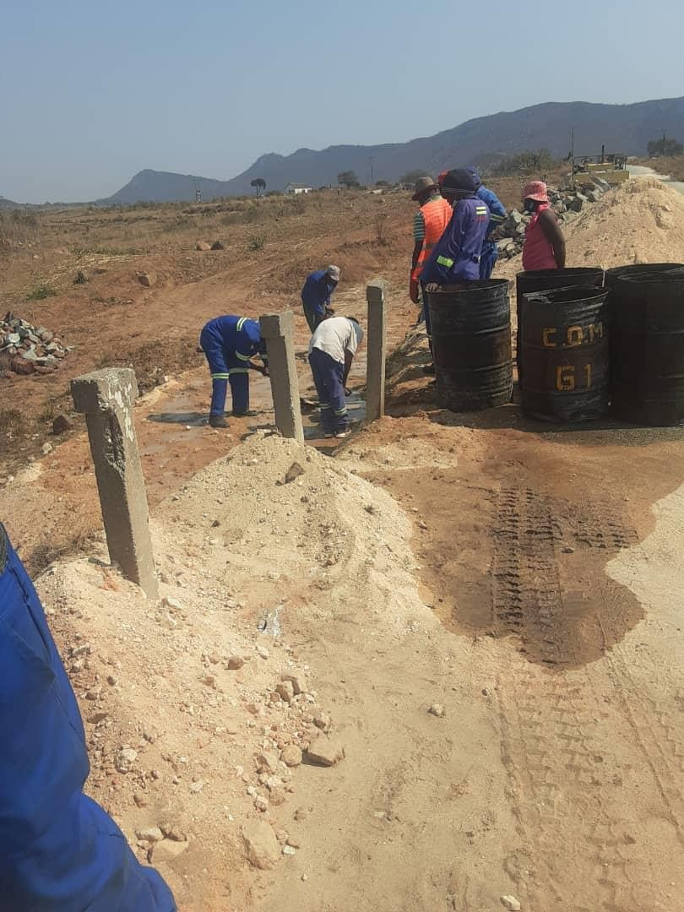

Gimboki shelvert work in Progress

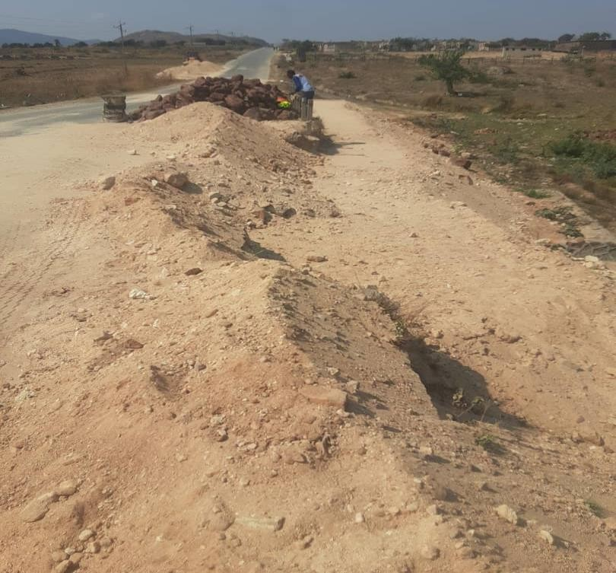

Gimboki shelvert work in Progress

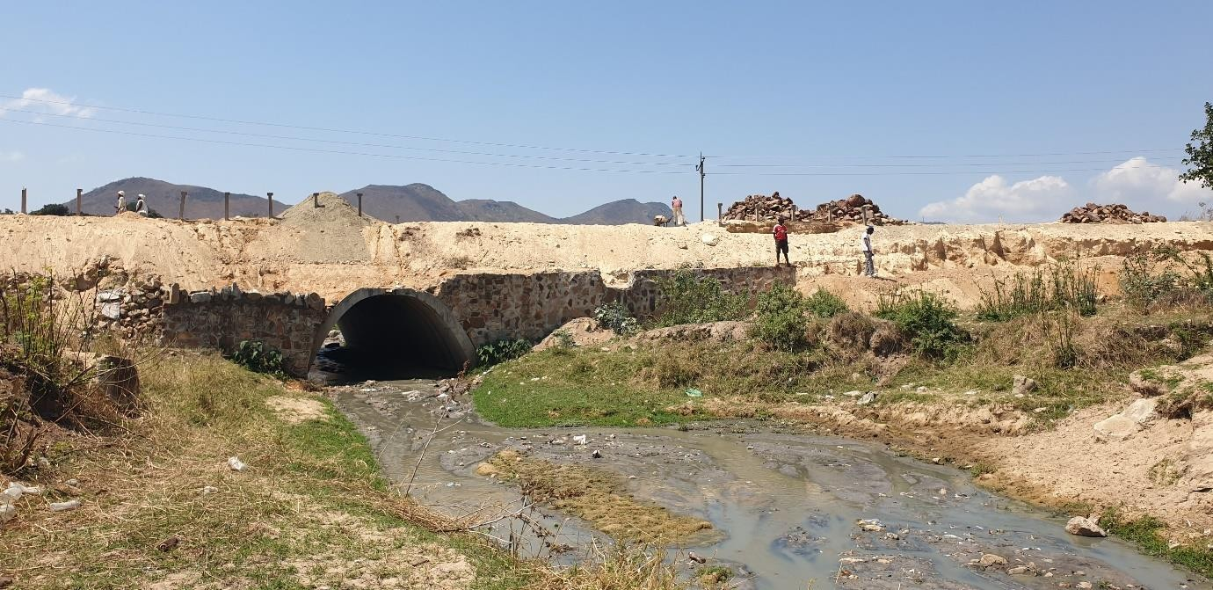

Gimboki shelvert work in Progress

**HOUSING & COMMUNITY SERVICES DEPARTMENTAL PERFOMANCE REPORT 2021**

**KEY PROJECTS AND ITEMS PROCURED**

|  |  |  |  |
| --- | --- | --- | --- |
| **NO** | **ITEM** | **SECTION** | **STATUS** |
| **1** | Executive Vehicle | Admin | Procured |
| **2** | Heavy duty Printers * 2 | Admin | Procured |
| **3** | Construction of public toilet – D/Mvura cemetery | Parks | Work in progress |
| **4** | Stadium | Com services | +90% Completion |
| **5** | Bush Mower | Parks | Procured |
| **6** | Rotary Mower | Parks | Procured |
| **7** | 3 Desk Computers & 1 Laptop | Housing | Donated |
| **8** | 3 Ton lorry | Parks | Procured |
| **9** | Chain Saw*2 | Parks | Procured |
| **10** | TV | Stadium | Procured |

The above items have been procured to date, with some of items being received end of December/Early January. Key milestones include;

* The 3 ton truck was recently procured will go a long way in addressing perennial transport challenges for the Parks section, which is charged with greening of the city parks and gardens, grass and tree cutting and cemetery management. Most of the tasks include ferrying goods and personnel to various workstations across the city. A reflection of the dire situation include the front page picture when our staff were pictured being transported sitting on a loan mower.
* The procurement of a bush mower has enabled the Parks section to attend to overgrown grass within a reduced period, while the Rotary mower is enabling the timeous mowing of lawn at the stadium.
* The Department had no printer and had to rely on 1 printer stationed at the LGA Accountant’s office. This was untenable given the volumes of printing the department undertakes on day to day basis.
* The Department also received 4 high specs computers from CLGF for the implementation of LADS.
* The Stadium was re-opened following an assessment by PSL and few matches were also hosted owing to major investments towards the refurbishment of the stadium.
* The Department also managed to repair a number of houses in Sakubva which had been damaged by rain.
* Markets have also been constructed and rehabilitated using Council resources as well as support from partner.

|  |  |  |  |
| --- | --- | --- | --- |
| **2021 FAILED PROJECTS** |  | **SECTION** | **ACTION** |
|  |  |  |  |
| Servicing Of Stands | Servicing of stands |  | DEFERRED TO 2022 |
| Jojo tank and borehole sinking |  |  | DEFERRED TO 2022 |
| Motor Vehicle |  | Vehicle for District Officer | DEFERRED TO 2022 |
| Executive desks |  | Director/DD/Secretary | DEFERRED TO 2022 |
| Executive chair swivel -Director |  |  | DEFERRED TO 2022 |
| Filling Cabinets |  | Registry | DEFERRED TO 2022 |
| Office Desk |  | For District Officer | DEFERRED TO 2022 |
| Office chairs |  |  | DEFERRED TO 2022 |
| Tea urn |  |  | DEFERRED TO 2022 |
| Visitors chairs(Director's office) |  |  | DEFERRED TO 2022 |
| Visitors Chairs |  | For District Officer | DEFERRED TO 2022 |
| Visitors Chairs |  | For District Officer | DEFERRED TO 2022 |
| Laptops for DO/Budget/CSO/AD |  | District Officer | DEFERRED TO 2022 |
| Printer Laser Jet M277N |  | District Officer | DEFERRED TO 2022 |
| Reconstruct public toilet and kitchen |  |  | DEFERRED TO 2022 |
| Sliding Gate |  | Sliding Gate For Main Entrance | DEFERRED TO 2022 |
| Chikanga office renovations |  |  | DEFERRED TO 2022 |
| Boundary Wall | Boundary wall for Csd Admin |  | DEFERRED TO 2022 |
| Construction Of Toilet And Kitchen | Construction of toilet and kitchen |  | DEFERRED TO 2022 |
| chairs |  | 450 chairs | DEFERRED TO 2022 |
| chairs |  | 4 visitors | DEFERRED TO 2022 |
| desks |  | 6 desks | DEFERRED TO 2022 |
| pa system |  | sakubva stadium | DEFERRED TO 2022 |
| computer |  | Office | DEFERRED TO 2022 |
| football pich |  | rehabillitation to turf | DEFERRED TO 2022 |
| goal post |  | Movable | DEFERRED TO 2022 |
| BOOK SHELVES |  | LOCKABLE | DEFERRED TO 2022 |
| CHAIRS |  | SWIVEL, JUNIOUR CHAIRS, VISITORS CAHIRS | DEFERRED TO 2022 |
| DESKS |  | LOCKABLE | DEFERRED TO 2022 |
| TABLES |  | FOR JUNIORS | DEFERRED TO 2022 |
| COMPUTERS |  | COMPUTER EQUIPMENT | DEFERRED TO 2022 |
| AREA016 |  | SERVICING | DEFERRED TO 2022 |
| AREA 3 |  | SERVICING | DEFERRED TO 2022 |
| MARKETS CONSTRUCTION |  | NEW MARKET | DEFERRED TO 2022 |
| SAKUBVA STADIUM |  | CONSTRUCTION | DEFERRED TO 2022 |
| BOUNDARY WALL |  | CHISAMBA GROUNDS | DEFERRED TO 2022 |
| CHIKANGA MULTI PURPOSE CENTRE |  | MULTIPURPOSE CENTRE | DEFERRED TO 2022 |
| FACTORY SHELL |  | COSTRUCTION | DEFERRED TO 2022 |
| NEW FLEA MARKET |  | CHIKANGA FLEA MKT BRICK BOUNDARY WALL | DEFERRED TO 2022 |
| STANDS SERVICING |  | BOTS AND BLOCK YARD | DEFERRED TO 2022 |
| GIMBOKI PRI |  | CONSTRUCTION OF PRIMARY SCH | DEFERRED TO 2022 |
| tables and chairs |  | meikels park | DEFERRED TO 2022 |
| tipping trailer |  | grass cutting | DEFERRED TO 2022 |
| tractor |  | heavy duty with accesories | DEFERRED TO 2022 |
| boom gate and guard room |  | lions view | DEFERRED TO 2022 |
| borehole |  | meikels park | DEFERRED TO 2022 |
| boundary wall |  | caravan park | DEFERRED TO 2022 |
| gazebo |  | meikels park caravan park | DEFERRED TO 2022 |
| jojo tank |  | meikels park | DEFERRED TO 2022 |

**CHALLENGES**

The major challenges facing the Department is shortage of tools of trade. The shortage of transport will remain a challenge for the Department which will impact negatively on service delivery. The Department is only serviced by two trucks where four should be the minimum. Council Cemeteries lack WASH facilities. The Toilet at Dangamvura cemetery is yet to be completed, and clients and citizens practicing open defecation. The Crematorium, at Yeovil cemetery is yet to be repaired as well.

While markets have been either constructed or rehabilitated, more resources are required as council pushes for decentralization in view of Covid-19.

Low and unsustainable tariffs on rented properties remains a big challenge. With most properties in Sakubva requiring major refurbishments due to decay over years, there is need to charge sustainable tariffs.

**EXPECTATION BEFORE YEAR END**

The following project are expected to be implemented before year end;

* Renovations/Repair of Housing Admin Offices
* Completion of the Public Toilet at Dangamvura Cemetery
* Digitization of Housing files in the registry
* Procure of Water pump for cemetery
* Roof construction at Hobhouse Primary School
* Turf upgrading (Sakubva Stadium)

**HEALTH DEPARTMENT**

|  |  |  |
| --- | --- | --- |
| **FIRE AND EMERGENCIES DIVISION** |  |  |
|  |  |  |
| New Ambulance | Delivered |  |
| New Ambulance conversion | By December 2021 |  |
| Command vehicle | Delivered |  |
|  |  |  |
| **CLINICAL SERVICES** |  |  |
| Vehicle DHS | Procured |  |
|  |  |  |
| **INFRASTRUCTURAL RENOVATIONS** |  |  |
| MIDH upgrade | In progress |  |
| Gimboki clinic construction | completed | joint venture involving CoM,Zimbabwe life International&Holiday Inn) |
| renovation and partition of TB unit and laboratory at Sakubva Clinic | completed | donor funded(AHF) |
| construction and fencing of incinerator at Sakubva Outpatient Department | completed | donor funded(Africa Ahead) |
| solarisation of Sakubva Health Centre | completed | donor funded(UNDP) |
|  |  |  |
| **ENVIRONMENTAL DIVISION** |  |  |
| **ANTI-MALARIA** |  |  |
| Anti-Malaria supervisory vehicle | received | Suzuki carry truck received |
| ANTI-MALARIA |  |  |
| Motor cycles | Delivery is expected by end of December 2021 |  |
| hudson pumps | Delivery is expected by end of December 2021 |  |
| CLEANSING |  |  |
| Skip Bins | Delivery is expected by end of December 2021 |  |
| Compactor trucks | Delivery is expected by end of December 2021 |  |
| Household bins | tender for 10 000 re advertised |  |
|  |  |  |

**HEALTH DEPARTMENT UNFUNDED CAPEX- 2021**

|  |  |
| --- | --- |
|  | **DEFFERED TO YEAR 2022** |
| **ITEM** | **COMMENT** |
| **FIRE AND EMERGENCIES DIVISION** |  |
| Utility vehicle | deferred to 2022 |
| **CLINICAL SERVICES** |  |
| **MIDH** |  |
| construction of admin block | deferred to 2022 |
| construction of external laundry room | deferred to 2022 |
| lab expansion and equipment | deferred to 2022 |
| **COMMUNITY NURSING** |  |
| double cab vehicle | deferred to 2022 |
| **HEALTH ADMIN** |  |
| administration utility vehicle | deferred to 2022 |
| **INFRASTRUCTURAL RENOVATIONS** |  |
| dangamvura clinic renovations | deferred to 2022 |
| Gimboki clinic fencing | deferred to 2022 |
| Health Depot renovations | deferred to 2022 |
| Fire and emergency services | deferred to 2022 |
| Chikanga Youth Centre Renovations | deferred to 2022 |
| Health Depot renovations | deferred to 2022 |
|  |  |
| **ENVIRONMENTAL DIVISION** |  |
|  |  |
| **CLEANSING** |  |
| Construction of a new compliant landfill(phase 1) | deferred to 2022 |
| Tractor | deferred to 2022 |
| Dump trailer | deferred to 2022 |
| Dozer | deferred to 2022 |
| cannalisation of Nyamauru river | deferred to 2022 |
| Waste management supervisory vehicle | deferred to 2022 |
|  |  |
| **INSPECTORATE** |  |
| Motor cycles (with trailers) | deferred to 2022 |
|  |  |

**ENGINEERING**

**PROJECTS COMPLETED IN 2021**

|  |  |  |  |  |  |
| --- | --- | --- | --- | --- | --- |
| **Section** | **Asset Classific ation** | **Asset or Project Description** | **Quanti ty** |  | **Performanc e 2021** |
| City Engineer Admin | Motor Vehicles |  | 1 |  | 1 vehicle procured |
| City Engineer Admin | Motor Vehicles | utility vehicles | 2 |  | 1x 5tonne truck , 2x 1  tonne truck |
| City Engineer Admin | Computer Equipment | GIS projects | **1** |  | 10%  procurement  stage |
| City Engineer Admin | infrastructure Assets | Completion and implementation n of master plan | **1** |  | masterplan approved and became operational from 16  August 2021 |
| City Engineer Admin | infrastructure Assets | In-line chlorinators for T section borehole | **1** |  | Chlorinators fitted |
| Electricity Jobbing | Motor Vehicles | Procurement of T-35 | **1** |  | 1 Truck procured |
| Roads | Plant And Machinery | procument of tipper | **2** |  | 2 tippers procured |
| Roads | infrastructure re Assets | FERUKA ROAD | **1** |  | Tar pothole patching completed |
| Roads | Infrastructure Assets | AERODROME ROAD | **1** |  | Resealing completed |
| Roads | Infrastructure Assets | AERODROME AIRSTRIP FENCING | **1** |  | Phase 1 OF Fencing Completed |
| Roads | infrastructure Assets | City wide Road signs | **60** |  | Signs installed |
| Roads | Plant and Equipment | Tractor Procurement | **1** |  | Tractor procured |
| Water Account | Motor Vehicles | Procurement of utility vehicles | **4** |  | 4 vehicles procured |
| Water Account | infrastructure Assets | DMAS | **3** |  | 3 DMAS installed in Hobhouse |
| Water Account | infrastructure Assets | Install bulk water meters from Odzani to Christmas Pass | **3** |  | 3 water meters installed |
| City Engineer Admin | Investment Property | fern hill & beira corridor | 1 |  | site offices established in Beira Corridor |
| City Engineer Admin | Investment Property | Fernhill SEZ | 1 |  | MOA with IDB signed |
| Water Account | infrastructure Assets | CONSTRUCTI ON OF SEWER PIPELINE | 1 |  | Yeovil |
| Water Account | infrastructure Assets | Development of water demand- management strategy | 1 |  | Done for Mutasa District |
| Water Account | infrastructure Assets | GIS MAPPING | 1 |  | Works in progress |
| Roads | infrastructure Assets | CITY WIDE ROAD MAINTANANC E | **1** |  | Work in progress |
|  |  |  |  |  |  |

**ENGINEERING**

**PROJECTS TO BE COMPLETED BY 31 DECEMBER 2021**

|  |  |  |  |  |  |
| --- | --- | --- | --- | --- | --- |
| **Section** | **Asset Classific ation** | **Asset or Project Description** | **Quanti ty** |  | **Performanc e 2021** |
| City Engineer Admin | Investment Property | fern hill & beira corridor | 1 |  | Signing of Contract with the Contractor for servicing |
| City Engineer Admin | Investment Property | Fernhill SEZ | 1 |  | MOA with IDB signed |
| Electricity Jobbing | infrastructure re Assets | Maonde electrification | 1 |  | Works in progress: External reticulation done on 94 blocks out of 114 blocks (fitting of distribution boards, MCBs,  connection of SWA cables on service lines).  Internal reticulation  outstanding. |
| Electricity Jobbing | infrastructure Assets | Migration of Traffic lights to LED with UPSs | 1 |  | Procurement for one set  traffic lights |
| Roads | Plant And Machinery | grader | 1 |  | Delivery of Grader |
| Roads | Plant And Machinery | Roller Compactor | 1 |  | Delivery of Roller  Compactor |
| Roads | infrastructure Assets | Magamba Road | 1 |  | handed over  to Department of roads Contractor  on site, work in progress |
| Roads | infrastructure Assets | Roads resealing | 1 |  | 4.3km resealed, work in progress for 1.4km resealing of  Bonda road |
| Roads | infrastructure Assets | Road Resealing | 1 |  | 4th street |
| Water Account | infrastructure Assets | 4  DEWATERIN G PUMPS/4 PRESSURE GAUGES | 1 |  | 1  dewatering pump 40% procured |
| Water Account | infrastructure Assets | Dangamvura Pipeline | 1 |  | Completion of pipeline construction |

**ENGINEERING**

**PROJECTS TO BE MOVED TO 2022**

|  |  |  |  |  |  |
| --- | --- | --- | --- | --- | --- |
| **Section** | **Asset Classific ation** | **Asset or Project Description** | **Quanti ty** |  | **DEFFERED TO 2022** |
| City Engineer Admin | Plant And Machinery | hydraulic tower wagon | 1 |  | Deferred |
| City Engineer Admin | Plant And Machinery | Procure 2000L mobile fuel bowser | 1 |  | Deferred |
| City Engineer Admin | infrastructure Assets | city centre local plan | 1 |  | Deferred |
| City Engineer Admin | infrastructure Assets | Climate resilience projects | 1 |  | Deferred |
| City Engineer Admin | infrastructure Assets | Provision for response to disaster | 1 |  | Deferred |
| City Engineer Admin | infrastructure Assets | capacitation and feasibility study urban  renewal | 1 |  | Deferred |
| City Engineer Admin | Land Buildings | Installation of roof-top mini- solar power plant at Civic centre | 1 |  | Deferred |
| Electricity Jobbing | infrastructure Assets | Installation of Solar & LED lights on regional & arterial routes | 1 |  | Deferred |
| Electricity Jobbing | infrastructure Assets | Migration to LED street lights | 2200.00 |  | Deferred |
| Gimboki Sewerage Works | infrastructure Assets | Preliminaries for Gimboki Phase3 STP  construction | 1 |  | Deferred |
| Gimboki Sewerage Works | infrastructure Assets | Water& Wastewater masterplan updating- Consultant | 1 |  | Deferred |
| Roads | Plant And Machinery | Excavator | 1 |  | Deferred |
| Roads | infrastructure Assets | 3 Foot Bridges Construction | 1 |  | Deferred |
| Roads | infrastructure Assets | Asphalt plant boiler replacement | 1 |  | Deferred |
| Roads | infrastructure Assets | CBD Old Rank Rehabilitation  / Renewal | 1 |  | Deferred |
| Roads | infrastructure Assets | Aerodrome Fencing | 1 |  | Completion of Fencing |
| Roads | infrastructure Assets | Guard rooms for Mutare Aerodrome | 2 |  | Deferred |
| Roads | infrastructure Assets | Waiting room for Arrivals and Departure for Mutare Aerodrome with  ablution | 1 |  | Deferred |
| Roads | infrastructure Assets | water bowser | 1 |  | Deferred |
| Sakubva Sewerage | infrastructure Assets | 400Mm Steel Pipes Replacement Trunk Main | 6 |  | Deferred |
| Sakubva Sewerage | infrastructure Assets | Replacement Of 375Mm  Trunk Mains Close To Sakubva  Works | 100 |  | Deferred |
| Sakubva Sewerage | infrastructure Assets | Upgrade Sakubva Sewer Mains And Manholes | 1 |  | 40 %  progress |
| Public Street Lighting | infrastructure Assets | Erect towerlights | 1 |  | Deferred |
| Town Sewerage | infrastructure Assets | Upgrade 2.5Km Of  Sewer line Along Dawson | 1 |  | Deferred |
| Water Account | Motor Vehicles | LAND CRUISER | 1 |  | Deferred |
| Water Account | infrastructure re Assets | 4  DEWATERIN G PUMPS/4 PRESSURE GAUGES | 1 |  | 1  dewatering pump 40% procured |
| Water Account | infrastructure Assets | Access Road Rehabilitation | 1 |  | NIL |
| Water Account | infrastructure Assets | AUTOLEVEL | 1 |  | NIL |
| Water Account | infrastructure Assets | BALL FLOAT VALVES | 1 |  | NIL |
| Water Account | infrastructure Assets | BULK WATER METERS | 1 |  | Deferred |
| Water Account | infrastructure Assets | CCTV INSTALLATIO N | 1 |  | NIL |
| Water Account | infrastructure Assets | CITYWIDE UPGRADE | 1 |  | NIL |
| Water Account | infrastructure Assets | CITYWIDE REPAIR | 1 |  | Deferred |
| Water Account | infrastructure Assets | City wide Water network revamp | 1 |  | Deferred |
| Water Account | infrastructure Assets | Construct 1km extension of 200mm water mainline from Chaminuka to  Greenside | 1 |  | Deferred |
| Water Account | infrastructure Assets | Dangamvura & Fern valley water project Augmentation n | 1 |  | Deferred |
| Water Account | infrastructure Assets | GENERATOR  -CUM WELDING  MACHINE | 1 |  | Deferred |
| Water Account | infrastructure Assets | Installation of online water & wastewater quality  monitoring probes | 1 |  | Deferred |
| Water Account | infrastructure Assets | Install ball valves and altitude meters at reservoirs | 1 |  | Deferred |
| Water Account | infrastructure Assets | MINI HYDRO POWER PLANT | 1 |  | Deferred |
| Water Account | infrastructure Assets | NRW & PILOT STUDY | 1 |  | Partnering with UZ to  do study 30% |
| Water Account | infrastructure Assets | ODZI WATER SCHEME | 1 |  | Deferred |